* 11 minutes

Azure can help you tackle tough business challenges. You bring your requirements, creativity, and favorite software development tools. Azure brings a massive global infrastructure that’s always available for you to build your applications on.

Let’s take a quick tour of the high-level services Azure offers.

## Azure overview

## Azure services

Here’s a big-picture view of the available services and features in Azure.

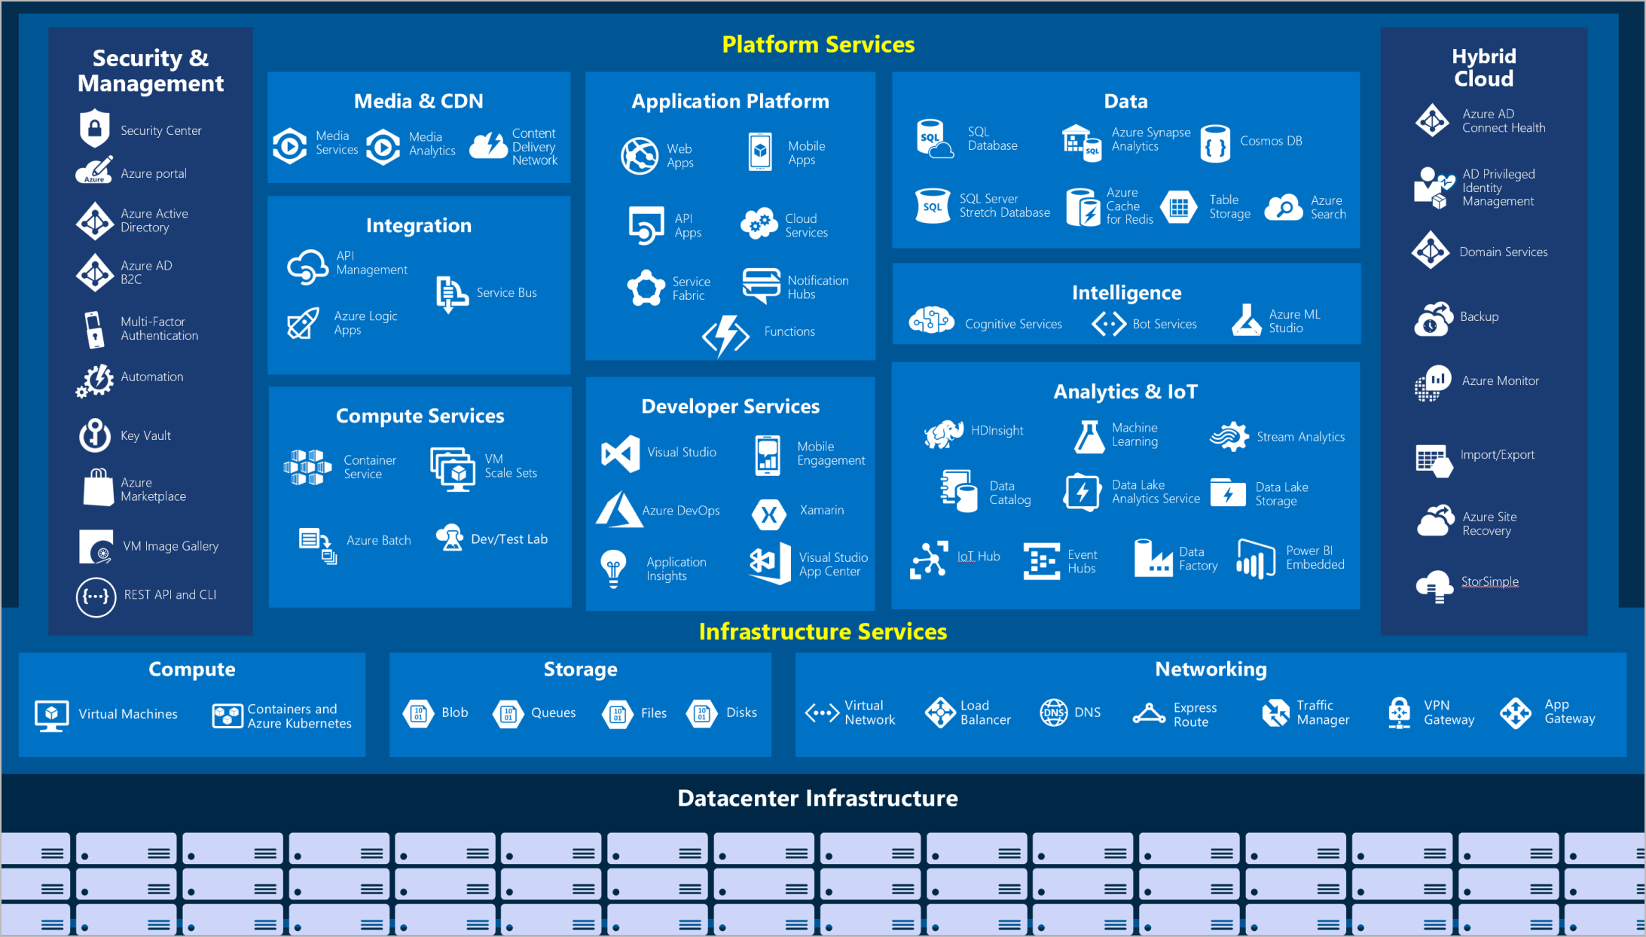

Diagram showing overall view of popular Azure services with sections for security and management, platform services, hybrid cloud, and infrastructure services.

Let’s take a closer look at the most commonly used categories:

* Compute
* Networking
* Storage
* Mobile
* Databases
* Web
* Internet of Things (IoT)
* Big data
* AI
* DevOps

### Compute

Compute services are often one of the primary reasons why companies move to the Azure platform. Azure provides a range of options for hosting applications and services. Here are some examples of compute services in Azure.

**Service name**

**Service function**

Azure Virtual Machines

Windows or Linux virtual machines (VMs) hosted in Azure.

Azure Virtual Machine Scale Sets

Scaling for Windows or Linux VMs hosted in Azure.

Azure Kubernetes Service

Cluster management for VMs that run containerized services.

Azure Service Fabric

Distributed systems platform that runs in Azure or on-premises.

Azure Batch

Managed service for parallel and high-performance computing applications.

Azure Container Instances

Containerized apps run on Azure without provisioning servers or VMs.

Azure Functions

An event-driven, serverless compute service.

### Networking

Linking compute resources and providing access to applications is the key function of Azure networking. Networking functionality in Azure includes a range of options to connect the outside world to services and features in the global Azure datacenters.

Here are some examples of networking services in Azure.

**Service name**

**Service function**

Azure Virtual Network

Connects VMs to incoming virtual private network (VPN) connections.

Azure Load Balancer

Balances inbound and outbound connections to applications or service endpoints.

Azure Application Gateway

Optimizes app server farm delivery while increasing application security.

Azure VPN Gateway

Accesses Azure Virtual Networks through high-performance VPN gateways.

Azure DNS

Provides ultra-fast DNS responses and ultra-high domain availability.

Azure Content Delivery Network

Delivers high-bandwidth content to customers globally.

Azure DDoS Protection

Protects Azure-hosted applications from distributed denial of service (DDOS) attacks.

Azure Traffic Manager

Distributes network traffic across Azure regions worldwide.

Azure ExpressRoute

Connects to Azure over high-bandwidth dedicated secure connections.

Azure Network Watcher

Monitors and diagnoses network issues by using scenario-based analysis.

Azure Firewall

Implements high-security, high-availability firewall with unlimited scalability.

Azure Virtual WAN

Creates a unified wide area network (WAN) that connects local and remote sites.

### Storage

Azure provides four main types of storage services.

**Service name**

**Service function**

Azure Blob storage

Storage service for very large objects, such as video files or bitmaps.

Azure File storage

File shares that can be accessed and managed like a file server.

Azure Queue storage

A data store for queuing and reliably delivering messages between applications.

Azure Table storage

Table storage is a service that stores non-relational structured data (also known as structured NoSQL data) in the cloud, providing a key/attribute store with a schemaless design.

These services all share several common characteristics:

* **Durable** and highly available with redundancy and replication.
* **Secure** through automatic encryption and role-based access control.
* **Scalable** with virtually unlimited storage.
* **Managed**, handling maintenance and any critical problems for you.
* **Accessible** from anywhere in the world over HTTP or HTTPS.

### Mobile

With Azure, developers can create mobile back-end services for iOS, Android, and Windows apps quickly and easily. Features that used to take time and increase project risks, such as adding corporate sign-in and then connecting to on-premises resources such as SAP, Oracle, SQL Server, and SharePoint, are now simple to include.

Other features of this service include:

* Offline data synchronization.
* Connectivity to on-premises data.
* Broadcasting push notifications.
* Autoscaling to match business needs.

### Databases

Azure provides multiple database services to store a wide variety of data types and volumes. And with global connectivity, this data is available to users instantly.

**Service name**

**Service function**

Azure Cosmos DB

Globally distributed database that supports NoSQL options.

Azure SQL Database

Fully managed relational database with auto-scale, integral intelligence, and robust security.

Azure Database for MySQL

Fully managed and scalable MySQL relational database with high availability and security.

Azure Database for PostgreSQL

Fully managed and scalable PostgreSQL relational database with high availability and security.

SQL Server on Azure Virtual Machines

Service that hosts enterprise SQL Server apps in the cloud.

Azure Synapse Analytics

Fully managed data warehouse with integral security at every level of scale at no extra cost.

Azure Database Migration Service

Service that migrates databases to the cloud with no application code changes.

Azure Cache for Redis

Fully managed service caches frequently used and static data to reduce data and application latency.

Azure Database for MariaDB

Fully managed and scalable MariaDB relational database with high availability and security.

### Web

Having a great web experience is critical in today’s business world. Azure includes first-class support to build and host web apps and HTTP-based web services. The following Azure services are focused on web hosting.

**Service name**

**Description**

Azure App Service

Quickly create powerful cloud web-based apps.

Azure Notification Hubs

Send push notifications to any platform from any back end.

Azure API Management

Publish APIs to developers, partners, and employees securely and at scale.

Azure Cognitive Search

Deploy this fully managed search as a service.

Web Apps feature of Azure App Service

Create and deploy mission-critical web apps at scale.

Azure SignalR Service

Add real-time web functionalities easily.

### IoT

People are able to access more information than ever before. Personal digital assistants led to smartphones, and now there are smart watches, smart thermostats, and even smart refrigerators. Personal computers used to be the norm. Now the internet allows any item that’s online-capable to access valuable information. This ability for devices to garner and then relay information for data analysis is referred to as IoT.

Many services can assist and drive end-to-end solutions for IoT on Azure.

**Service name**

**Description**

IoT Central

Fully managed global IoT software as a service (SaaS) solution that makes it easy to connect, monitor, and manage IoT assets at scale.

Azure IoT Hub

Messaging hub that provides secure communications between and monitoring of millions of IoT devices.

IoT Edge

Fully managed service that allows data analysis models to be pushed directly onto IoT devices, which allows them to react quickly to state changes without needing to consult cloud-based AI models.

### Big data

Data comes in all formats and sizes. When we talk about big data, we’re referring to *large* volumes of data. Data from weather systems, communications systems, genomic research, imaging platforms, and many other scenarios generate hundreds of gigabytes of data. This amount of data makes it hard to analyze and make decisions. It’s often so large that traditional forms of processing and analysis are no longer appropriate.

Open-source cluster technologies have been developed to deal with these large data sets. Azure supports a broad range of technologies and services to provide big data and analytic solutions.

**Service name**

**Description**

Azure Synapse Analytics

Run analytics at a massive scale by using a cloud-based enterprise data warehouse that takes advantage of massively parallel processing to run complex queries quickly across petabytes of data.

Azure HDInsight

Process massive amounts of data with managed clusters of Hadoop clusters in the cloud.

Azure Databricks

Integrate this collaborative Apache Spark-based analytics service with other big data services in Azure.

### AI

AI, in the context of cloud computing, is based around a broad range of services, the core of which is machine learning. Machine learning is a data science technique that allows computers to use existing data to forecast future behaviors, outcomes, and trends. Using machine learning, computers learn without being explicitly programmed.

Forecasts or predictions from machine learning can make apps and devices smarter. For example, when you shop online, machine learning helps recommend other products you might like based on what you’ve purchased. Or when your credit card is swiped, machine learning compares the transaction to a database of transactions and helps detect fraud. And when your robot vacuum cleaner vacuums a room, machine learning helps it decide whether the job is done.

Here are some of the most common AI and machine learning service types in Azure.

**Service name**

**Description**

Azure Machine Learning Service

Cloud-based environment you can use to develop, train, test, deploy, manage, and track machine learning models. It can auto-generate a model and auto-tune it for you. It will let you start training on your local machine, and then scale out to the cloud.

Azure ML Studio

Collaborative visual workspace where you can build, test, and deploy machine learning solutions by using prebuilt machine learning algorithms and data-handling modules.

A closely related set of products are the *cognitive services*. You can use these prebuilt APIs in your applications to solve complex problems.

**Service name**

**Description**

Vision

Use image-processing algorithms to smartly identify, caption, index, and moderate your pictures and videos.

Speech

Convert spoken audio into text, use voice for verification, or add speaker recognition to your app.

Knowledge mapping

Map complex information and data to solve tasks such as intelligent recommendations and semantic search.

Bing Search

Add Bing Search APIs to your apps and harness the ability to comb billions of webpages, images, videos, and news with a single API call.

Natural Language processing

Allow your apps to process natural language with prebuilt scripts, evaluate sentiment, and learn how to recognize what users want.

### DevOps

DevOps brings together people, processes, and technology by automating software delivery to provide continuous value to your users. With Azure DevOps, you can create *build* and *release* pipelines that provide continuous integration, delivery, and deployment for your applications. You can integrate repositories and application tests, perform application monitoring, and work with build artifacts. You can also work with and backlog items for tracking, automate infrastructure deployment, and integrate a range of third-party tools and services such as Jenkins and Chef. All of these functions and many more are closely integrated with Azure to allow for consistent, repeatable deployments for your applications to provide streamlined build and release processes.

**Service name**

**Description**

Azure DevOps

Use development collaboration tools such as high-performance pipelines, free private Git repositories, configurable Kanban boards, and extensive automated and cloud-based load testing. Formerly known as Visual Studio Team Services.

Azure DevTest Labs

Quickly create on-demand Windows and Linux environments to test or demo applications directly from deployment pipelines.

## Next unit: Get started with Azure accounts

[Continue](https://docs.microsoft.com/en-us/learn/modules/intro-to-azure-fundamentals/get-started-with-azure-accounts/)